Adaptive Learning Skill:
Making a Sandwich

Materials Needed:
- Bread of your choice
- Sunflower butter (or peanut butter)
- Jelly
- Two knives
- Plate
- CLC Video (Included)

Introduction/ Discussion:
Adaptive skills come from adaptive behavior, or the conceptual, social, and practical skills that individuals have learned and use in their daily lives.

Preparing students for independent living. One aspect of this is teaching students to feed and care for themselves and others! This means learning how to cook is especially important. When you teach cooking, you can teach and discuss nutrition, self-care, safety, and nurturing. Making sunflower butter and jelly sandwiches is both yummy and simple to make :)

Activities:
- Discuss the activity for the day and why it is important.
- Review the visual describing the steps of the process.
- Model the task
- Have the student check off the items as each step is completed.
- Have the student complete the task, independently or with /prompt support.

Review/ Summary:
- Discuss the steps of the process.
- You may have the student state or place the ingredients in the appropriate order.
Sunflower seed butter and jelly sandwich
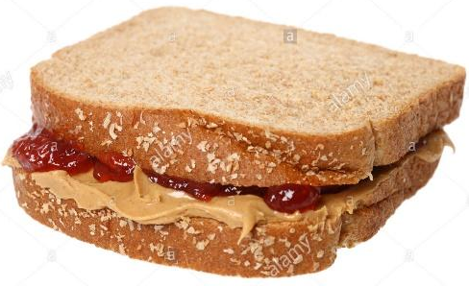

I need: a plate bread
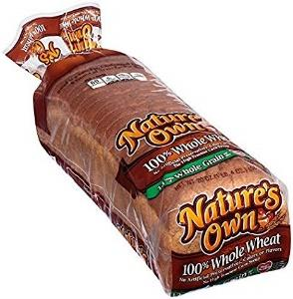

jam sunflower seed butter

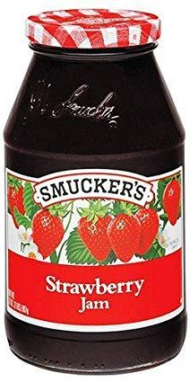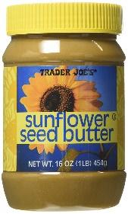

2 knives

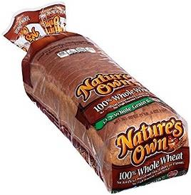 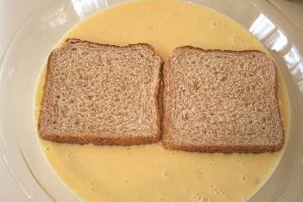 2 pieces of bread

Spread sunflower seed butter on 1 bread

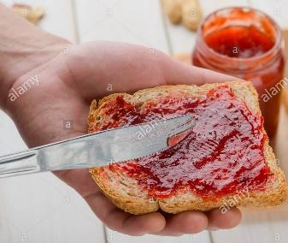 Spread jelly on other bread with clean knife

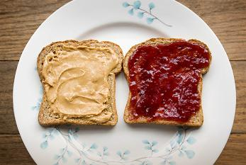
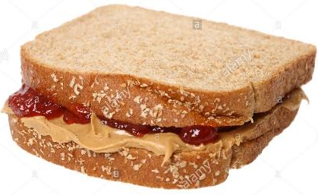Put bread together

Eat and enjoy

